**Gracious Germents**

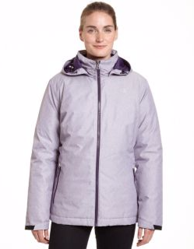

**DESCRIPTION:**

Adapt to changing weather conditions with our Technical Heather Jacket and its 3-in-1 design.

Combine or remove layers as the weather requires.

Heather shell jacket has a DWR (durable water repellent) finish for wind- and water-resistance.

Lightweight shell with an elasticized drawcord hood and hem, plus pockets.

Removable, anti-pill microfleece liner traps body heat for added warmth.

Interior smart pocket and media portal.

Team up the liner and shell for exceptional warmth when the temps drop.

Units Per Pack: 1

Fabric Content: 100% Polyester

Country of Origin: Imported

**ADDITIONAL INFORMATION**

Weight: 0.5 kg

Dimensions: 10 × 8 × 3 cm

Size: S, M, L, XL,

Price: $20.00